THIS PROTECTIVE EQUIPMENT
MUST BE WORN
IN THIS AREA
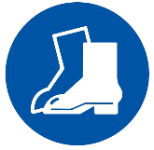

P.P.E Requirements
- Long sleeve and long pants cotton clothing
- Hearing Protection
- Eye protection
- Steel capped footwear
- High visibility clothing

